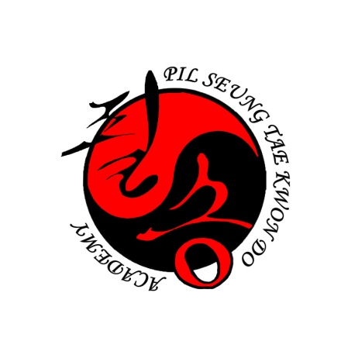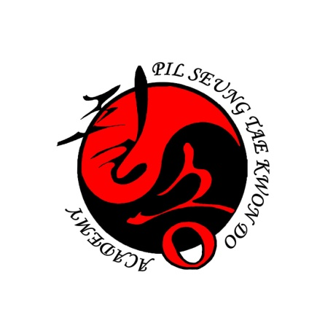Terms

**Blocking ‘Makgi’ Terms**

* [Absorbing Block](http://www.blackbeltwiki.com/taekwondo-absorbing-block) - Bada Makgi
* Deflecting Block - Geodeo Makgi
* [High Block](http://www.blackbeltwiki.com/high-block) - Ulgool Makgi
* [Inside Block](http://www.blackbeltwiki.com/inside-block) - An Makgi
* [Kicking Block](http://www.blackbeltwiki.com/taekwondo-kicking-block) - Cha Makgi
* [Knife Hand Block](http://www.blackbeltwiki.com/knife-hand-block) - Sonnal Makgi
* Single Middle [Knife Hand Block](http://www.blackbeltwiki.com/knife-hand-block) - Han Sonnal Bakat Momtong Makgi
* Double Middle [Knife Hand Block](http://www.blackbeltwiki.com/knife-hand-block) - Sonnal Bakat Momtong Makgi
* [Low Block](http://www.blackbeltwiki.com/low-block) - Arae Makgi
* Middle Block - Momtong Makgi
* [Mountain Block](http://www.blackbeltwiki.com/taekwondo-mountain-block) - Santul Makgi
* Single Mountain Block - Oesanteul Makgi
* [Outside Block](http://www.blackbeltwiki.com/outside-block) - Bakat Makgi
* Outside Forearm Block - Bakat Palmok Makgi
* [Double Outside Block](http://www.blackbeltwiki.com/taekwondo-double-outside-block) - Hecheo Makgi
* [Pressing Block](http://www.blackbeltwiki.com/taekwondo-pressing-block) - Nulleo Makgi
* [Scissors Block](http://www.blackbeltwiki.com/taekwondo-scissors-block) - Kawi Makgi or Gawi Makgi
* [Supporting Block](http://www.blackbeltwiki.com/taekwondo-supporting-block) or Assisted Block - Geodeureo Makgi
* Tripping Block - Georeo Makgi
* X-Block or Cross Block - Otgoreo Makgi

**Kicking ‘Chagi’ Terms**

* Axe Kick - Naeryeo Chagi
* Back Kick - Dwi Chagi
* Crescent Kick - Bandal Chagi
* Flying Back Kick - Twi-myo Dwi Chagi
* Flying Side Kick - Twi-myo Yeop Chagi
* Front Kick - Ap Chagi
* Hook Kick - Huryeo Chagi
* Jumping Front Kick - Eedan Ap Chagi
* Knee Strike - Moreup Chigi (use chigi ‘strike’)
* Push Kick - Meereo Chagi
* Roundhouse Kick - Dollyo Chagi ("Dole-ya-cha-gee")
* Side Kick - Yeop Chagi ("Yup-cha-gee")
* Spinning Hook Kick - Dwi Huryeo Chagi
* Tornado Kick – Dol Gae Chagi or Dolmyo Chagi

**Counting Terms**

* One - Hana ("Ha-na")
* Two - Dul ("Dhool")
* Three - Set ("Set")
* Four - Net ("Net")
* Five - Dasot ("Da-sut")
* Six - Yasot ("Yo-sut")
* Seven - Ilgup ("Eel-gope")
* Eight - Yodol ("Yo-dull")
* Nine - Ahop ("Ah-hope")
* Ten - Yeol ("Yull")

**Sparring Terms**

* Blue – Chung
* Red – Hong
* Break – Kalyeo
* Continue – Kyesok
* End – Keoman
* Winner – Seung (E.G. Chung Seung – Blue Wins)

**General Terms**

* Attention - Charyut ("Chari-yut")
* Begin or Start - Sijak
* Bow – Kyungnet
* Grandmaster Instructor -
* Master Instructor - Sabomnim
* Instructor – nim
* Uniform - Dobok
* Flag - Kuk Ki
* Ready position – Choon Bee

**Forms**

* [Form 1](http://www.taekwondoanimals.com/taekwondo-form-1) - Taegeuk Il Jang (Yellow -> Green)
* [Form 2](http://www.taekwondoanimals.com/taekwondo-form-2) - Taegeuk Ee Jang (Green -> Purple)
* [Form 3](http://www.taekwondoanimals.com/taekwondo-form-3) - Taegeuk Sam Jang (Purple ->Blue)
* [Form 4](http://www.taekwondoanimals.com/taekwondo-form-4) - Taegeuk Sa Jang (Blue -> High Blue)
* [Form 5](http://www.taekwondoanimals.com/taekwondo-form-5) - Taegeuk Oh Jang ( High Blue -> Brown)
* [Form 6](http://www.taekwondoanimals.com/taekwondo-form-6) - Taegeuk Yuk Jang (Brown -> High Brown)
* [Form 7](http://www.taekwondoanimals.com/taekwondo-form-7) - Taegeuk Chil Jang (High Brown -> Red)
* [Form 8](http://www.taekwondoanimals.com/taekwondo-form-8) - Taegeuk Pal Jang (Red -> Bodan)

**Punching ‘Jirugi’ Terms**

* Strike - Chigi
* Elbow Strike - Palkup Chigi
* Arc Hand Strike - An Jin Son Chigi
* Knife Hand Strike - Son Kal Chigi
* Palm Strike - Ba Tang Son Chigi
* Spear Hand Strike - Pyong Son Keut Chigi
* Back Fist - Doong Chumok
* Hammer Fist - Me Chumok